Kindergarten
- 1- Box Yellow Wood Pencils #2 Ticonderoga
- 4- Box 24 Crayola Crayons
- 1- Scissors- Fiskars Brand
- 2- Glue Sticks
- 1 pkg. Thin Highlighters
- 1- School Supply Box
- Small nap blanket
- Change of Clothes in a labeled Ziplock bag
- 4 Dry erase markers
- Crayola brand Watercolors
- 2- green folders
- 2-red folders
- 2- blue folders

Trinity Lutheran School Supply List
2021-2022

1st & 2nd Grades
- 2- School Supply Box
- 2- Box Yellow Wood Pencils #2 Ticonderoga
- 3- Box 24 Crayola Crayons
- 1- Colored Pencils 24 count
- 1- 8 count Markers
- 2-Crayola brand Water Colors- 16 colors
- 1- Scissors- Fiskars Brand
- 1- bottle White Elmer’s Glue
- 8- Glue Sticks
- 2- Spiral Notebooks 70 page
- 1- Primary Journal
- 2- Plastic Yellow Folders
- 2- Plastic folders any color

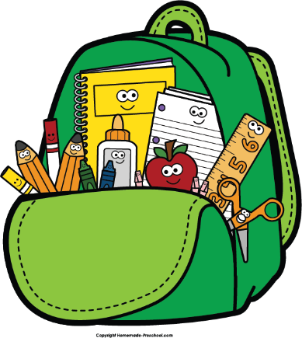

3rd, 4th & 5th Grades
- 1- School Supply Box
- 1- Box Yellow Wood Pencils #2 Ticonderoga
- 1- Box 24 Crayola Crayons
- 1- Colored Pencils 24 count
- Markers 10 ct. - 1 box narrow & 1 box wide
- Crayola brand Water Colors- 16 colors
- 1- Scissors- Fiskars Brand
- 12- Glue Sticks
- 2- Spiral Notebooks 70 page
- 2 pkg WIDE lined notebook paper
- 1- Assignment Planner
- 3- Pocket Folders (blue, green & purple)
- ESV Bible
- 1- 1 ½” 3 ring binder

5th Grade
- Protractor- Dual
- Compass (circle drawing)
- Scientific calculator
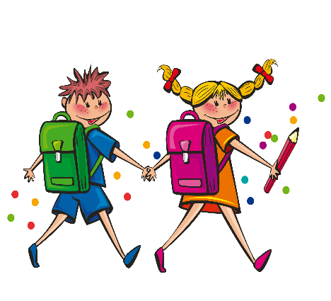

ALL STUDENTS
- Water bottle, Lunchbox & Backpack
- 2- Ream Printer Paper
- 2- Clorox wipes
- Ziplock baggies- 1 box gallon, 1 box sandwich
- 2 boxes Kleenex
- 100 Plain Paper Plates (Not Styrofoam)
- 8 oz Paper Cups (not solo)
- 1- 100ct plastic forks
- 1- 100ct plastic spoons
- 1 Bottle Hand Sanitizer

